VIRTUAL CAMP KITE CHALLENGE

**WHAT YOU WILL NEED**

**1: SHEET A4 PAPER**

**2: DRINKING STRAW**

**3: STICKY TAPE**

**4: 5M OF COTTON**

**5: STRIP OF TISSUE PAPER**

**TOOLS**

**A: RULER**

**B: PENCIL**

**C: HOLE PUNCH**

**BEFORE YOU STICK ON THE STRAW YOU CAN DECORATE THE SIDES AND WINGS TO MAKE IT LOOK LIKE A SPACE SHUTTLE, STEALTH PLANE, FAIRY, BUTTERFLY OR ANYTHING ELSE.**

**No-Wind**

The No-Wind is a simple kite to build that can fly with very little wind (up to 10 km / h): just even walking pulling it behind like a dog on a leash.  
To make the sail of a No-Wind you use an A4 sheet of paper.

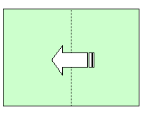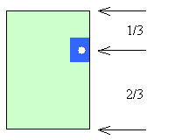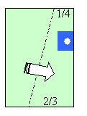

Fold the sheet in half; about a third of the length (7cm), apply a reinforcement of tape and make a hole (an office punch is fine, failing: a pair of scissors). Draw a line from a quarter of the edge (4cm) closest to the hole up to two thirds (10cm) of the other edge. Fold a flap and fix with two pieces of tape.

        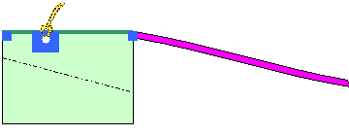

Cut a drinking straw to the same as the wingspan and fix it on the wings with a piece of tape at each end.

Prepare the bridle with a piece of string of about 30 cm, fold it in half, make a loop with the two free ends and tighten. The opposite side should be fixed with a larks head knot on the hole of the kite. For the Tail (for decorative purposes and stability) use a strip of about 1cm by 100cm; fix it at the end of the Spine, from the side opposite the Bridle with tape. For the flying line you must use a very thin string to attach to the bridle with another larks head hitch.

